**Software Requirements Specification (SRS)**

**For**

**Project: Ecommerce Website Features**

iAssure International Technologies Pvt. Ltd

**Effective Date: Mar 23rd, 2021**

|  |  |
| --- | --- |
| **Document Owner:** | iAssure International Technologies Pvt. Ltd |

**Version History**

|  |  |  |  |
| --- | --- | --- | --- |
| Version | Date | Description | Author |
| 1.0 | Mar 23rd, 2021 | Requirement Document | Ms. Chetana Wajage |
|  |  |  |  |

**Approval**

*(By signing below, all Approvers agree to all terms and conditions outlined in this Agreement.)*

|  |  |  |  |
| --- | --- | --- | --- |
| Approvers | Role | Signed | Approval Date |
|  |  |  |  |
|  |  |  |  |
|  |  |  |  |

Table of Contents

1. Home Page 5

1.1. Header Section 5

1.2. Middle Section 6

1.3. Footer Section 9

2. Blogs 12

2.1. Blog details page 12

3. Section page 13

3.1. Filter 13

3.2. Sort Product By 13

3.3. Add to Cart 13

3.4. Add to Wishlist 14

3.5. Pagination 14

4. Product Category Page 15

4.1. Filter 15

4.2. Sort Product By 15

4.3. Add to Cart 15

4.4. Add to Wishlist 16

4.5. Pagination 16

5. Product Sub Category Page 17

5.1. Filter 17

5.2. Sort Product By 17

5.3. Add to Cart 17

5.4. Add to Wishlist 17

5.5. Pagination 18

6. Product Details Page 19

6.1. Select Quantity 19

6.2. Select Color 19

6.3. Select Size 20

6.4. Add to Wishlist 20

6.5. Add to Cart 20

6.6. Related Products 20

7. System Security 22

7.1. Log In 22

7.2. Forgot Password 23

7.3. Register (Sign Up) 27

8. Shopping cart 29

8.1. Quantity 29

8.2. Remove Product 29

8.3. Move To Wishlist 29

8.4. Checkout 29

8.5. Coupon code 30

8.6. Wishlist 30

9. Checkout page 31

9.1. Payment Method 31

9.2. Shipping Address 32

9.3. Order Reviews 34

10. Order Confirmation page 36

11. My Profile (Customer Personal Area) 37

11.1. Account Dashboard 37

11.2. Account Information 38

11.3. Saved Cards 40

11.4. Address Book 41

11.5. My Product Reviews 44

11.6. My Wishlist 44

11.7. My Orders 45

# Use Case diagram

The below is the use case diagram of the customer

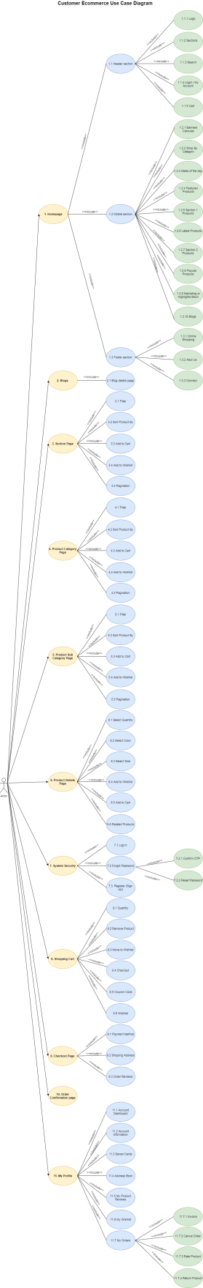

Home Page

* When a user enters the URL of the website in the address bar of the browser and presses the ‘Enter’ key on the keyboard then it will load the home page of the site.
* The homepage will get divided into 3 sections, i.e., Header, Middle & Footer section, and accordingly, it will display the modules available on the site.

Header Section

* In the top navigation of the header section, it will show the logo, sections, search bar, login, and cart icon.

Logo

* The logo of the site will be available at the center
* The client will provide us high resolution PNG/JPEG image of the logo
* The logo must be clickable and it will always redirect to the home page after clicking on the logo

Sections

* It will show the listing of sections of the site.
* 4-5 sections will be available
* When the customer mouse hover on a particular section then it will show the listing of available categories of that sections

Search

* The header navigation also includes a search bar to search the sections, categories, products, and more.
* This will helps the customer to get what they want quickly from the website.

Login/My Account

* This option is available above the shopping cart icon in the top navigation bar of the header section of the homepage.
* When a customer clicks on this option, it will open the sign in modal.
* If the customer is logged in to the site then after mouse hover, it will show My account options like ‘My Profile’, ‘My Orders’, ‘My Wishlist’, and ‘Sign Out’
* Sign out option is available to terminate the session and to get logged out of their account.
* Clicking on the ‘Sign Out’ option, it will terminate the session and the user gets logged out of their account.
* After clicking on the ‘Sign Out’ option, it will shot the message “You have been logged out Successfully!”

Cart

* This icon will be available at the right corner in the top navigation bar of the header section of the homepage.
* Once the customer added the product to the cart, it will show the count of products added in the cart on the shopping cart icon.
* When a customer clicks on the shopping cart icon then it will open a shopping cart page to view in depth details of the products.

Middle Section

* + 1. Banners Carousel
* The middle section of the website includes banners carousel which show the product, site, and offers information.
* The size & placement of the banners will remain fixed.
* 4-5 sliding banners will be available.
* It will show previous & next arrows on the left & right sides of the banner.
* When a customer clicks on the previous arrow, it will show the previous banner, and clicking on the next arrow, it will show the next banner.

Shop By Category

* Here it will show 8 categories. blocks
* For each category, it will display the category image and category name.
* When the customer clicks on the particular category then it will show the listing of products of that selected category.

Deals of The Day

* Here it will show 5 products with previous & next arrow.
* Clicking on the previous icon will show the previous product, and clicking on the next icon will show the next product.
* For each product, it will display product image, product name, brand name, product price, price after discount, and percentage discount.
* The customer can add the product to the wishlist by clicking on the heart icon and the heart icon gets filled with blue color to showcase that this product is already added to the wishlist.
* Clicking on a particular product image will redirect the customer to the product detail page.
* When a customer clicks on the ‘Add To Cart’ button then the product gets added to the cart.
  + 1. Featured Products
* Here it will show 5 products which are highlighted by the admin with previous & next arrow.
* Clicking on the previous icon will show the previous product, and clicking on the next icon will show the next product.
* For each product, it will display product image, product name, brand name, product price, price after discount, and percentage discount.
* The customer can add the product to the wishlist by clicking on the heart icon and the heart icon gets filled with blue color to showcase that this product is already added to the wishlist.
* Clicking on a particular product image will redirect the customer to the product detail page.
* When a customer clicks on the ‘Add To Cart’ button then the product gets added to the cart.
  + 1. Section 1 Products
* Here it will show 5 products of section 1 with previous & next arrow.
* Clicking on the previous icon will show the previous product, and clicking on the next icon will show the next product.
* For each product, it will display product image, product name, brand name, product price, price after discount, and percentage discount.
* The customer can add the product to the wishlist by clicking on the heart icon and the heart icon gets filled with blue color to showcase that this product is already added to the wishlist.
* Clicking on a particular product image will redirect the customer to the product detail page.
* When a customer clicks on the ‘Add To Cart’ button then the product gets added to the cart.
  + 1. Latest Products
* Here it will show 5 new arrival products with previous & next arrow.
* Clicking on the previous icon will show the previous product, and clicking on the next icon will show the next product.
* For each product, it will display product image, product name, brand name, product price, price after discount, and percentage discount.
* The customer can add the product to the wishlist by clicking on the heart icon and the heart icon gets filled with blue color to showcase that this product is already added to the wishlist.
* Clicking on a particular product image will redirect the customer to the product detail page.
* When a customer clicks on the ‘Add To Cart’ button then the product gets added to the cart.
  + 1. Section 2 Products
* Here it will show 5 products of section 2 with previous & next arrow.
* Clicking on the previous icon will show the previous product, and clicking on the next icon will show the next product.
* For each product, it will display product image, product name, brand name, product price, price after discount, and percentage discount.
* The customer can add the product to the wishlist by clicking on the heart icon and the heart icon gets filled with blue color to showcase that this product is already added to the wishlist.
* Clicking on a particular product image will redirect the customer to the product detail page.
* When a customer clicks on the ‘Add To Cart’ button then the product gets added to the cart.
  + 1. Popular Products
* Here it will show 5 fastest moving products with previous & next arrow.
* Clicking on the previous icon will show the previous product, and clicking on the next icon will show the next product.
* For each product, it will display product image, product name, brand name, product price, price after discount, and percentage discount.
* The customer can add the product to the wishlist by clicking on the heart icon and the heart icon gets filled with blue color to showcase that this product is already added to the wishlist.
* Clicking on a particular product image will redirect the customer to the product detail page.
* When a customer clicks on the ‘Add To Cart’ button then the product gets added to the cart.
  + 1. Marketing or Highlights Block
* This block will showcase the banner with ‘Shop Now’ button.
* Clicking on the ‘Shop Now’ button will redirect to the listing page where the listing of products of the category/section available on the banner will be shown.
  + 1. Blog
* Listing of 3 blog posts will be shown here in this section with the previous & next arrow
* When a customer clicks on the previous arrow, it will show the previous blog post, and click on the next arrow, it will show the next blog post.
* Each blog post includes a banner image, posted date, title, and author.
* Clicking on each blog post will redirect to a detailed blog page where it will showcase the details of that blog

Footer Section

* + 1. Online Shopping
* In the footer section, it will show categories of available sections.
  + 1. About Us
* Quick links will be available for the CMS Pages likes Contact us, About us, Blogs, Privacy Policy, Terms & Conditions, Photo Gallery, and FAQ

### About Us

* This option is available in the footer section of the homepage.
* When a user tap on this option then it will open a CMS page.
* This page will contain all the general information about the website.
* The information is in textual, pictorial, or video format.
* This information helps the customer to know better about the site.
* The content of this page is admin manageable.

### FAQ

* This option is available in the footer section of the homepage.
* When a user tap on this option then it will open a CMS page.
* This page will show a listing of all the frequently asked questions for the customer’s help of various topics like shipping, order tracking, delivery, cancellation, return, exchange, sign up, payment, and coupons
* This will make it easy for the customers to find what they want, answer the concerns without frequently getting in contact with the admin.
* The content of this page is admin manageable.
* When a customer clicks on the particular question it will explore the answer of that question and when again tap on the same question then the answer gets hide.

### Contact Us

* This option is available in the footer section of the homepage.
* When a user tap on this option then it will open a CMS page.
* This page will show all the contact information of the website such as an address, contact number, email, and location on the map.
* This page also includes a form to get in touch with the website admin.

**Available Fields**

* The fields available in the contact form are as below
  + Name (text field) – This field is to enter the full name
  + Email (text field) – This field is to enter the email
  + Phone number (text field) – This field is to enter the phone number
  + Message (paragraph) – This field is to enter the message
  + Send (button) – This button sends the request to the admin

**Validation**

* All fields are mandatory.
* If the user missed any mandatory fields then it will show an error after clicking on the ‘Send’ button.

**Result**

* After clicking on the ‘Send’ button, it will validate all data and if everything is correct then the request will be submitted to the site administrator and it will show the successful message “Thanks for contacting us. We'll get back to you as soon as possible.”
* Once the contact form is submitted, an admin will receive an email.
* Further communication will take place outside the website.

### Privacy Policy

* This option is available in the footer section of the homepage.
* When a user tap on this option then it will open a CMS page.
* This page will show all the information about the privacy policy of the site.
* It showcases a statement that discloses some or all the ways information the website/ admin party gathers, uses, discloses, and manages a customer or client's data.
* This information will be available for the user to read and proceed further with using the website.
* This page fulfills a legal requirement to protect a user or client's privacy.
* The content of this page is admin manageable.

### Terms & Conditions

* This option is available in the footer section of the homepage.
* When a user tap on this option then it will open a CMS page.
* This page will show all the information about the terms & conditions for using the website.
* A Terms and Conditions may include the terms, the rules, and the guidelines of acceptable behavior and other useful sections to which customers must agree to use or access the website.
* The content of this page is admin manageable.

### Photo Gallery

* This option is available in the footer section of the homepage.
* When a user tap on this option then it will open a page where it will show all images/photos added by the admin.
  + 1. Connect
* Social media links will be available to follow the site on social media like Facebook, Instagram, Twitter, and YouTube.

Blogs

* When the customer clicks on the blog option, then it will redirect to this page
* This page will showcase all blogs posted by the admin.
* For each blog, it will display information that includes banner image, title, posted date, author name (posted by), and count of comments.
* Pagination will be provided to navigate from one page to another page at the bottom of the listing.
* The customer can view the page number on which they are currently on.
* The customer can click on the next arrow to redirect to the next page to view the blog listing and click on the previous arrow to go back to the blog page

Blog details page

* When a customer clicks on a particular blog post then he/she can view detailed information of that blog.
* The detail page will include the banner image of the blog, title, content, blog image, posted date, author name (posted by), and count of comments.
* The customer has an option to leave a comment on the blog post.

Section page

* When the customer mouse hovers on a particular section then it will show the listing of available categories of that section.
* When a customer taps on a particular section then it will show the listing of all products of that section with various categories.
* On this page, it will also show breadcrumb (current page's location within a navigational hierarchy) at the left corner
* This page will display filters on left side and the right side, it will show the listing of products
* For a single product that includes a product image, product name, brand name, product price, and discount percentage if available.
* If any discount is offered by the admin for a particular product then it will show the original price with strikethrough and price after discount. E.g., ~~Rs.1000~~  Rs. 600
* Clicking on a particular product image will redirect the customer to the product detail page.

Filter

* The customer can apply the filter parameters to find the particular product
  + Category
  + Sub-Category
  + Price range
  + Different Sizes
  + Product Colours
  + Brands
  + Main Product Attributes
* After selecting the particular filter it will refresh the product listing and show the products according to the selected filter.

Sort Product By

* The customer can find the particular product by applying below sorting parameters
  + Name A -> Z
  + Name Z -> A
  + Price Low -> High
  + Price High -> Low

Add to Cart

* When a customer clicks on this button then the product gets added to the cart and show the success message “Product added to cart successfully.”

Add to Wishlist

* The customer has an option to save the particular product to the wishlist by clicking on the heart icon.
* Only registered customers can save the product to the wishlist.
* Clicking on the heart icon for each product will check the customer is logged in to the site or not.
* If the customer is logged in to the site then the product gets saved to the wishlist and the heart icon gets filled with blue color to showcase that this product is already added in the wishlist.
* It will show the successful message “Product added in wishlist successfully.”
* If the customer is not logged in to the site then clicking this option will show the message “Need to Sign In. Please Sign In First”

Pagination

* By default all products will be listed on the page.
* The customer has an option to select how many product they want to view on each page i.e., 10, 20, 40, and 80 products
* Pagination will be provided to navigate from one page to another page at the bottom of the listing.
* The customer can view the page number on which they are currently on.
* The customer can click on next arrow to redirect to next page to view product listing and click on previous arrow to go back to the previous page

Product Category Page

* When a customer taps on the product category option then it will show the listing of the products of that category
* When the customer mouse hovers on a particular category then it will show the listing of available sub categories of that category.
* On this page, it will also show breadcrumb (current page's location within a navigational hierarchy) at the left corner
* This page will display filters on left side and the right side, it will show the listing of products
* For a single product that includes a product image, product name, brand name, product price, and discount percentage if available.
* If any discount is offered by the admin for a particular product then it will show the original price with strikethrough and price after discount. E.g., ~~Rs.1000~~  Rs. 600
* Clicking on a particular product image will redirect the customer to the product detail page.

Filter

* The customer can apply the filter parameters to find the particular product
  + Sub-Category
  + Price range
  + Different Sizes
  + Product Colours
  + Brands
  + Main Product Attributes
* After selecting the particular filter it will refresh the product listing and show the products according to the selected filter.

Sort Product By

* The customer can find the particular product by applying below sorting parameters
  + Name A -> Z
  + Name Z -> A
  + Price Low -> High
  + Price High -> Low

Add to Cart

* When a customer clicks on this button then the product gets added to the cart and show the success message “Product added to cart successfully.”

Add to Wishlist

* The customer has an option to save the particular product to the wishlist by clicking on the heart icon.
* Only registered customers can save the product to the wishlist.
* Clicking on the heart icon for each product will check the customer is logged in to the site or not.
* If the customer is logged in to the site then the product gets saved to the wishlist and the heart icon gets filled with blue color to showcase that this product is already added in the wishlist.
* It will show the successful message “Product added in wishlist successfully.”
* If the customer is not logged in to the site then clicking this option will show the message “Need to Sign In. Please Sign In First”

Pagination

* By default all products will be listed on the page.
* The customer has an option to select how many product they want to view on each page i.e., 10, 20, 40, and 80 products
* Pagination will be provided to navigate from one page to another page at the bottom of the listing.
* The customer can view the page number on which they are currently on.
* The customer can click on next arrow to redirect to next page to view product listing and click on previous arrow to go back to the previous page

Product Sub Category Page

* When a customer taps on the product sub category option then it will show the listing of the products of that sub category
* On this page, it will also show breadcrumb (current page's location within a navigational hierarchy) at the left corner
* This page will display filters on left side and the right side, it will show the listing of products
* For a single product that includes a product image, product name, brand name, product price, and discount percentage if available.
* If any discount is offered by the admin for a particular product then it will show the original price with strikethrough and price after discount. E.g., ~~Rs.1000~~  Rs. 600
* Clicking on a particular product image will redirect the customer to the product detail page.

Filter

* The customer can apply the filter parameters to find the particular product
  + Price range
  + Different Sizes
  + Product Colours
  + Brands
  + Main Product Attributes
* After selecting the particular filter it will refresh the product listing and show the products according to the selected filter.

Sort Product By

* The customer can find the particular product by applying below sorting parameters
  + Name A -> Z
  + Name Z -> A
  + Price Low -> High
  + Price High -> Low

Add to Cart

* When a customer clicks on this button then the product gets added to the cart and show the success message “Product added to cart successfully.”

Add to Wishlist

* The customer has an option to save the particular product to the wishlist by clicking on the heart icon.
* Only registered customers can save the product to the wishlist.
* Clicking on the heart icon for each product will check the customer is logged in to the site or not.
* If the customer is logged in to the site then the product gets saved to the wishlist and the heart icon gets filled with blue color to showcase that this product is already added in the wishlist.
* It will show the successful message “Product added in wishlist successfully.”
* If the customer is not logged in to the site then clicking this option will show the message “Need to Sign In. Please Sign In First”

Pagination

* By default all products will be listed on the page.
* The customer has an option to select how many product they want to view on each page i.e., 10, 20, 40, and 80 products
* Pagination will be provided to navigate from one page to another page at the bottom of the listing.
* The customer can view the page number on which they are currently on.
* The customer can click on next arrow to redirect to next page to view product listing and click on previous arrow to go back to the previous page

Product Details Page

* When a customer clicks on product image from the product listing page, it will redirect to this page where it will display the following details of the chosen product.
  + Product Name
  + Product Code
  + Multiple product images in carousel
  + Brand Name
  + Product Description
  + Product Features
  + Product price
  + Discount offers
  + Available Colors
  + Available Sizes
  + Product Attributes
  + Availability (in stock / out of stock)
  + Product average rating
  + Reviews- The customer can view a listing of all ratings & reviews given by other customers for this product.
* After the mouse hover on the image the customer can view a zoom-in view of the product image.
* If any discount is offered by the admin for a particular product then it will show the original price with strikethrough and price after discount. E.g., ~~Rs.1000~~ Rs. 600
* On the detail page select quantity, select size, select color, add to cart, and add to wishlist options will be available.
* The related products block is also available on this page below product details.

Select Quantity

* The customer has the facility to select the quantity of the product.
* By default one quantity of the product is shown on this page.
* The customer can increase or decrease the product quantity with the help of + & - options.

Select Color

* If the product has multiple colors then all available colors of that product is shown in the pictures.
* The customer has the facility to select the color of the product.
* When customer mouse hover on the particular color then the product image will be shown in that color.
* When a customer adds this product to the cart then the selected color of the product will be added to the cart.

Select Size

* If the products has multiple sizes then all available sizes of that product is shown.
* The customer has the facility to select the size of the product.
* Size chart will be available here.
* When a customer adds this product to the cart then the selected size of the product will be added to the cart.

Add to Wishlist

* The customer has an option to save the particular product to the wishlist by clicking on the heart icon.
* Only registered customers can save the product to the wishlist.
* Clicking on the heart icon for each product will check the customer is logged in to the site or not.
* If the customer is logged in to the site then the product gets saved to the wishlist and the heart icon gets filled with blue color to showcase that this product is already added in the wishlist.
* It will show the successful message “Product added in wishlist successfully.”
* If the customer is not logged in to the site then clicking this option will show the message “Need to Sign In. Please Sign In First”

Add to Cart

* When a customer clicks on this option then the product will be added to the cart and show the success message “Product added to cart successfully.”
* If the user tries to add the same product which is already in the cart then it will show the message “This product is already in your cart.”

Related Products

* Here it will show 5 products related to this product with previous & next arrow.
* Clicking on the previous icon will show the previous product, and clicking on the next icon will show the next product.
* For each product, it will display product image, product name, brand name, product price, price after discount, and percentage discount.
* The customer can add the product to the wishlist by clicking on the heart icon and the heart icon gets filled with blue color to showcase that this product is already added to the wishlist.
* Clicking on a particular product image will redirect the customer to the product detail page.
* When a customer clicks on the ‘Add To Cart’ button then the product gets added to the cart.

**Note:** The below are the features of the user login

System Security

Log In

* The customer can log in to their account by entering the registered details.

**Available Fields**

* On this page, the below fields are available
  + Email ID (text field) - This field is to enter the email address.
  + Password (text field) - This field is to enter the registered account password
  + Sign In (button) - This button is to validate the credentials.
  + Eye (icon) - This is to view & hide the password.
  + Sign Up (link) – This link is to go to the sign up modal
  + Forgot Password? (link) – This link is to go to the forgot password modal

**Validations**

* Both fields are mandatory.
* If the admin missed any mandatory fields then it will show an error after clicking on the ‘Sign In’ button.
* The admin has the facility to view the text entered in the password field by clicking on the show eye icon and can again hide the text entered in the password field by clicking on the hide eye icon.
* For the email id field are standard email validation must be followed
* The validation for the password field is as follows
  + This field must be case sensitive
  + In the password field, spaces are not allowed at the beginning and the end
  + This field should include min 6 & max 40 characters
  + This field should include anything from alphabets (uppercase & lowercase), symbols, and digits

**Result**

* If the admin missed the email id field then it will show an error message “Please enter your email”
* If the admin missed the password field then it will show an error message “Please enter your password.”
* After clicking on the ‘Sign In’ button it will check entered details are valid or not.
* If details are valid then the customer gets logged in to the site and show the success message “You have been successfully logged in”
* If the details are invalid then show the error message “Please enter valid Email ID and Password”

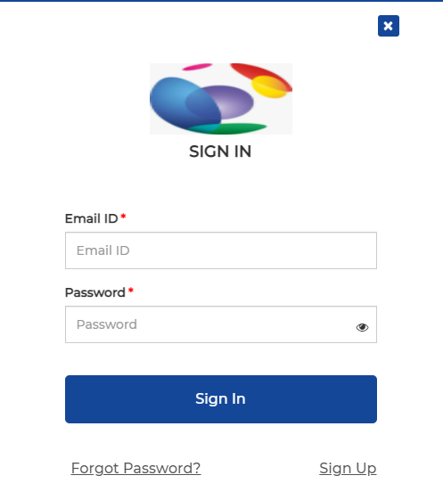

Figure - Sign In

Forgot Password

* The forgot password link will be available on the Sign in modal if the customer forgets the account password.
* Clicking on this link will open a forgot password page.
* The customer needs to enter a registered mobile number to receive an OTP

**Available Fields**

* On this page, the below fields are available
  + Email ID (text field) - This field is to enter the email address.
  + Send OTP (button) - This button is to send the OTP
  + Sign In (link) – This link to redirect back to sign in page

**Validation**

* The email Id field is mandatory.
* If the customer missed any mandatory field then it will show an error after clicking on the ‘Send OTP’ button.
* For the email field are standard email validation must be followed

**Result**

* If the admin missed the email id field then it will show an error message “Please enter your email”
* Clicking on the ‘Send OTP’ button will check the email is registered or not.
* If email is registered then it will show the success message “OTP sent to your registered Email ID” and it will show confirm OTP modal.
* If email is not registered then it will show the message “This Email ID is not registered”
* The customer will receive an OTP on that entered email id after clicking on the ‘Send OTP’ button
* Clicking on the ‘Sign In’ link, it will go back to the sign in modal.
* Clicking on cancel icon it will close the modal.

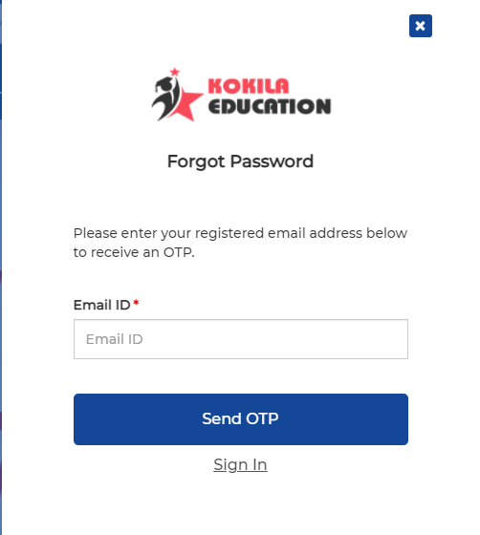

Figure - Forgot Password

* + 1. Confirm OTP
* The admin user will enter the OTP received to them and click on the ‘Submit’ button to validate the OTP.

**Available Fields**

* On this page, the below fields are available
  + Enter OTP (text field) – This field is to enter OTP received on email
  + Submit (button) – This button is to validate the OTP
  + Resend OTP (button) - This button is to again send the OTP
  + Found your Password? Sign In (link) – This link to redirect back to sign in page

**Validation**

* Enter OTP field is mandatory.
* If the customer missed any mandatory field then it will show an error after clicking on the ‘Submit’ button.
* The validation for enter OTP field is as follows
  + OTP must be 4 digits in length
  + Only numbers are accepted
  + OTP should not include symbols, alphabets
  + OTP will be valid for 10 minutes

**Result**

* If the admin user missed any mandatory field then it will show the error message “Please enter an OTP.”
* Clicking on the ‘Submit’ button will validate the OTP.
* If OTP is valid then it will show the success message “OTP Verified Successfully.” and the user will redirect to the reset password modal to set the password.
* If OTP is incorrect then it will show the error message “Please enter valid OTP”
* Clicking on the ‘Resend OTP’ button will again send the OTP to the registered email id and show the success message “OTP re-sent to your registered Email ID”
* Clicking on cancel icon it will close the modal.

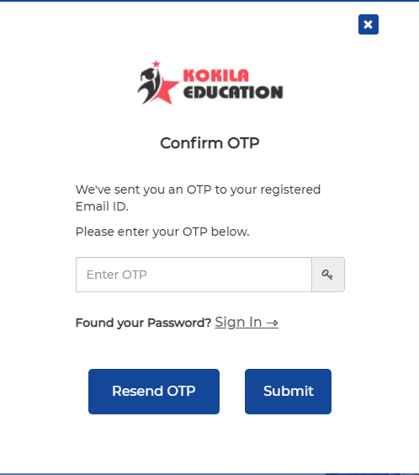

Figure - Confirm OTP

* + 1. Reset Password

**Available Fields**

* On this modal, the below fields are available
  + New Password (text field) - This field is to enter the new password
  + Confirm Password (text field) - This field is to repeat the account password which is entered in the new password field
  + Submit (button) - This button is to reset the account password
  + Eye (icon) - This is to view & hide the password.

**Validations**

* Both fields are mandatory.
* If the customer missed any mandatory field then it will show an error after clicking on the ‘Submit’ button.
* The validation for the password field is as follows
  + This field must be case sensitive
  + In the password field, spaces are not allowed at the beginning and the end
  + This field should min 6 & max 40 characters
  + The field should include anything from alphabets, symbols, and digits
* The customer has the facility to view the text entered in the password field by clicking on the show eye icon and can again hide the text entered in the password field by clicking on the hide eye icon.

**Result**

* If the new password does not match with confirm password field, it will show the error message “Passwords don’t match”
* After clicking on the ‘Reset Password’ button, it will verify the password and show the successful message “Your password has been reset successfully!!”
* The customer needs to go back to the sign in modal to again login to the site.
* Clicking on cancel icon it will close the modal.

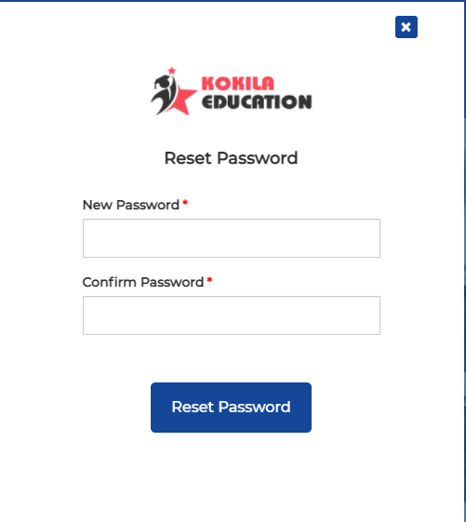

Figure - Reset Password

Register (Sign Up)

* The new customer needs to sign up to the site for purchasing the products.
* The new customer can register anytime to the site by selecting the signup modal.
* The signup link will be available on the Sign in modal.

**Available Fields**

* Clicking on this link will open a signup modal where the below fields are available
  + First Name (text field) – This field is to enter the first name of the full name
  + Last Name (text field) - This field is to enter the last name of the full name
  + Email Id (text field) - This field is to enter the email address.
  + Mobile Number (text field) - This field is to enter the mobile number.
  + Pincode (text field) - This field is to enter the pincode
  + Create Password (text field) - This field is to enter the account password
  + Confirm Password (text field) - This field is to repeat the account password which is entered in the password field
  + Sign Up (button) - This button is to submit the entered data.
  + Eye (icon) - This is to view & hide the password. This icon will be available for both password & confirm password fields.

**Validations**

* All fields are mandatory.
* If the customer missed any mandatory fields then it will show an error after clicking on the ‘Submit’ button.
* The customer has the facility to view the text entered in the password field by clicking on the show eye icon and can again hide the text entered in the password field by clicking on the hide eye icon.
* The validation for first name & last name fields are as follows
  + The field should include only alphabets (uppercase, lowercase characters)
  + The field should not include symbols, digits, punctuation, or characters from multiple languages
* For the email id field are standard email validation must be followed
* The validation for the mobile number field is as follows
  + This field must accept characters as per country validation (10)
  + Only numbers are accepted
* The validation for the pincode field is as follows
  + This field must accept only 6 characters
  + Only numbers are accepted
* The validation for the password field is as follows
  + The field must be case sensitive
  + In the password field, spaces are not allowed at the beginning and the end
  + The field should min 6 & max 40 characters
  + The field should include anything from alphabets, symbols, and digits

**Result**

* If the customer missed any mandatory fields then it will show an error message “This field is required”
* If the customer missed the email id field then it will show an error message “Please enter your email”
* If the customer enters the invalid first name & last name then it will show an error message “Name should only contain letters”
* If the customer enters the invalid email id then it will show an error message “Please enter valid email”
* If the customer enters the invalid mobile number then it will show an error message “Please enter valid mobile number”
* If the customer enters the invalid pincode then it will show an error message “Please enter 6 digit pincode”
* If the customer enters the invalid password then it will show an error message “Please enter at least 6 characters”
* If the password does not match with confirm password field, it will show an error message “Password do not match”
* After clicking on the ‘Submit’ button, it will validate all data and if everything is correct then the request will be submitted to the site administrator and it will show the successful message for the customer’s account created successfully.
* The customer will receive an email notification after the account is created successfully.

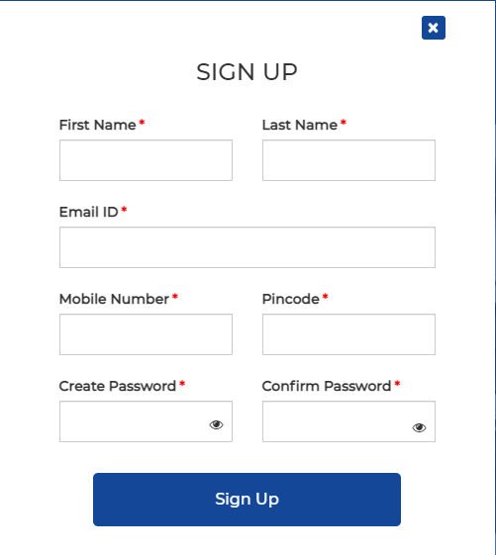

Figure - Sign Up

Shopping cart

* Clicking on the ‘Cart icon will redirect to this page to view in depth details of the products.
* On this page, it will also show breadcrumb (current page's location within a navigational hierarchy) at the center.
* The shopping cart page will hold the list of all products that have already been added to the cart within the customer’s journey.
* On this page, it will show the following details of the single product
  + Product Image
  + Product Name
  + Item wise Price with discounted price and discount percentage
  + Price
  + Select Quantity
  + Size
  + Color
  + Total
* If any discount is offered by the admin for a particular product then it will show the original price with strikethrough and price after discount. E.g., ~~Rs.1000~~ Rs. 600
* The customer can view the price summary which includes cart total, order total, delivery charges, discount, tax, coupon discount, and grand amount.
* The wishlist block is also available on this page below product listing.

Quantity

* The customer can increase/decrease the product quantity from the shopping cart page.
* If the customer changes the quantity of the product then the price will get auto updated.

Remove Product

* The customer can remove a product from the shopping cart by clicking on the delete icon which is available for each product.

Move To Wishlist

* The customer can move the product to the wishlist by clicking on the ‘Move to Wishlist’ button.

Checkout

* The customer will be redirected to the checkout page by clicking on the ‘Proceed to Checkout’ button.

Coupon code

* The ‘Apply Discount’ link is available in front of the coupon discount.
* Clicking on the ‘Apply Discount’ link will open the apply coupon modal.
* Clicking on the close icon, it will close the modal.
* On this modal, it will show enter coupon code textbox to enter the coupon code.
* On the modal, it will also show listing of all available coupons with a checkbox to select the coupon.
* Each coupon code will include coupon code, amount saves, description, and its terms & conditions.
* After entering the coupon code, it will show maximum saving amount on the modal.
* The user will click on ‘Apply’ button to apply the coupon and the discount amount will be shown in front of the coupon discount.
* The grand total will be shown by deducting the coupon discount.

Wishlist

* Here it will show 5 products which are added by the customer to the wishlist with previous & next arrow.
* Clicking on the previous icon will show the previous product, and clicking on the next icon will show the next product.
* For each product, it will display product image, product name, brand name, product price, price after discount, and percentage discount.
* The customer can remove the product from wishlist by clicking on filled heart icon and it will show success message “Product removed from wishlist successfully.”
* Clicking on a particular product image will redirect the customer to the product detail page.
* When a customer clicks on the ‘Add To Cart’ button then the product gets added to the cart.

Checkout page

* The system will open the checkout page by clicking on the ‘Proceed to Checkout’ button on the cart page.
* On this page, it will also show breadcrumb (current page's location within a navigational hierarchy) on the center.

Payment Method

* Available payment methods are credit/debit card, net banking, and Bhim UPI.
* The customer will select the preferred payment method by selecting the radio button available in front of each method name.

1. **Saved Cards**

* If the customer has previously placed an order and has used the credit/debit card as the payment method and the card details are recorded in the system, then the card details will be pre populated.
* The customer will select the radio button available in front of the card details and click on the ‘Pay’ button to make the payment from this card.

1. **Credit/Debit Card**

* If the customer selects a ‘Credit/Debit Card’ as a payment method then it will show fields to enter card details.

**Available Fields**

* Below fields are available in the card details form
  + Card Number (text field) – This field is to enter the card number
  + Name on card (text field) - This field is to enter the name of the cardholder
  + Expiry Month (dropdown) – This field is to select the expiry month of the card. In the dropdown, it will show 01 (Jan) to 12 (Dec) month listing
  + Expiry Year (dropdown) – This field is to select the expiry year of the card. In the dropdown, it will show the listing of the 2020 year to 2049 years
  + CVV (text field) – This field is to enter the CVV of the card
  + Pay (button) – This button is to check card details are valid or not
  + Save this card for faster payment (checkbox) - The customer can save these card details by clicking on the checkbox

**Validations**

* All fields are mandatory.
* If the admin missed any mandatory fields then it will show an error after clicking on the ‘Pay’ button.
* The validation for the name on card field is as follows
  + This field should include only alphabets (uppercase, lowercase characters)
* The validation for card number field is as follows
  + This field should include only 16 characters
  + This field should include only digits
* The validation for CVV field is as follows
  + This field should include only 3 characters
  + This field should include only digits

**Result**

* After clicking on the ‘Pay’ button, it will check card details are valid or not.
* If the card is invalid then it will show an error message.
* If the card is valid then it will make payment for the order.
* It will show the payment receipt when payment is successful.
* If payment failed then it will show failure message.

1. **Bhim UPI**

* The customer will enter the UPI Id and clicks on the ‘Pay’ button then it will show the page where it will show 5 minutes of decreasing time to make payment and the payment request will be shown to that particular app to make the payment.
* When a customer makes the payment from the app then here it will show a payment receipt when payment is successful.
* If payment failed then it will show failure message.

1. **Net Banking**

* If the customer selects ‘Netbanking’ as a payment method then it will show the option to select the bank.
* The customer will select the bank from the available options and after clicking on the ‘Pay’ button and then it will redirect to the netbanking payment gateway page to make a payment.
* It will show the payment receipt when payment is successful.
* If payment failed then it will show failure message.

Shipping Address

* If the customer has previously placed an order and has addresses recorded in the system, the primary address will be pre populated along with the name.
* The customer will select the radio button available in front of the address to which address they want to deliver the order.
* If the customer wants to deliver the order to another address that is not on the list then he/she has the facility to click on the ‘Add New Address’ button which is placed below the saved primary address
* It will open a modal after clicking on the ‘Add New Address’ button to enter the address details.

**Available Fields**

* Below fields are available on the modal
  + Full Name (text field) – This field is to enter the full name
  + Mobile Number (text field) - This field is to enter the mobile number.
  + Email (text field) – This field is to enter the email address
  + House No./Office No. (text field) – This field is to enter the house/office number
  + Address (text field) – This field is to enter the address
  + Zip/Postal code (text field) – This field is to enter the pincode of the area
  + Address Type (dropdown) – This field is to select the address type. In the dropdown, it will show options like Home (All day delivery), Office/Commercial (Delivery between 10 AM – 5 PM), Relative (All day delivery), or Friend (All day delivery)
  + Save Address (Button) – This button is to save the address
  + Cancel (Button) – This button is to close the modal

**Validations**

* Full name, mobile number, email, zip/postal code, address, and address type fields are mandatory.
* If the admin missed any mandatory fields then it will show an error after clicking on the ‘Save Address’ button.
* The validation for the full name field is as follows
  + This field should include only alphabets (uppercase, lowercase characters)
  + This field should not include symbols, digits, punctuation, or characters from multiple languages
* The validation for the mobile number field is as follows
  + This field must accept characters as per country validation (10)
  + Only numbers are accepted
* For the email field are standard email validation must be followed
* The validation for zip/postal code field is as follows
  + This field must accept only 6 characters
  + Only numbers are accepted
* The address field will have auto complete fashion i.e. when an admin starts type town or city name then the address will appear in the dropdown.
* The admin will select the address from the dropdown

**Result**

* If the user missed the email field then it will show an error message “Please enter your email.”
* If the user missed the address type field then it will show an error message “Please select Address type.”
* If the customer enters the invalid full name then it will show an error message “Name should only contain letters.”
* If the customer enters the invalid mobile number then it will show an error message “Please enter valid mobile number.”
* If the customer enters the invalid email then it will show an error message “Please enter valid email.”
* If the cutomer missed the address field then it will show an error message “This feild is required”
* After clicking on the ‘Save Address’ button, it will validate all data and if everything is correct then it will add the address record in the list.
* It will show the success message after adding address “Address added successfully.”
* After clicking on the ‘Cancel’ button and close icon, it will close the modal.

Order Reviews

* The customer is presented with their product details and price details
* For each product, it will show product image, product name, color, size, price, quantity, and subtotal
* In price details, it will show cart total, order total, delivery charges, discount, tax, and grand total.
* The customer needs to agree to the terms & conditions for placing the order.
* Clicking on the ‘I agree to the Terms & Condition link’ will show terms & conditions for using the site in modal.
* Clicking on the cancel icon and cancel button will close the terms & conditions popup.
* The customer can select the shipping time for delivering the product.
* The customer can place an order by clicking on the ‘Place Order’ button and it will show the success message “Order placed successfully”

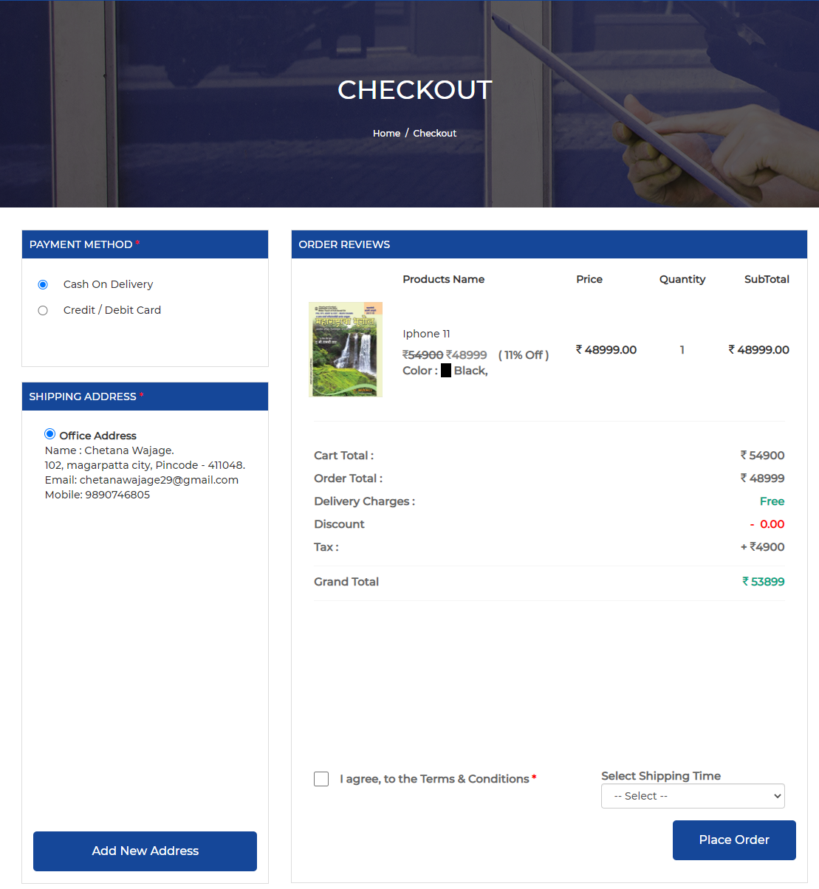

Figure - Checkout

Order Confirmation page

* The system will redirect the customer to the success page and show the order confirmation message “Your order is placed successfully.” with order details.
* Order details include order id, order date & time, shipping time, shipping address, payment method, order summary (cart total, shipping, discount, tax, order total, and total amount), and product details (product image, product name, color, size, price, quantity, and subtotal)
* The system will also send an email to the customer & admin with order details.
* The customer can redirect to the ‘My Orders’ section by clicking on the ‘Back to My Orders’ link.

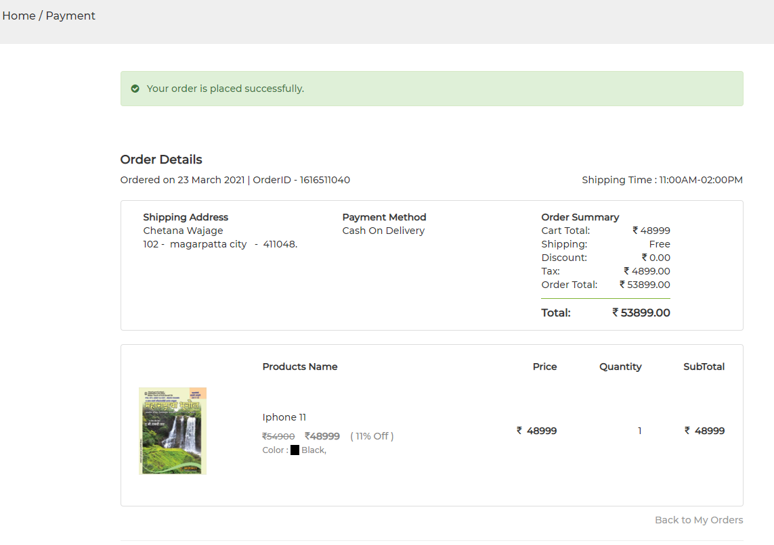

Figure - Order Confirmation Page

My Profile (Customer Personal Area)

* When logged in customer clicks on the ‘My Profile’ option then this page will appear
* On this page, it will also show breadcrumb (current page's location within a navigational hierarchy) on the center
* This page will have below options
  + Account Dashboard
  + Account Information
  + Saved Cards
  + Addresses Book
  + My Orders
  + My Wishlist
  + My Product Reviews

Account Dashboard

* The account dashboard page will show the overview of the customer’s account.
* On this page, it will show contact information, default billing address, and default shipping address
* The customer has the facility to edit the contact information & address information.
* Clicking on the edit button for billing & shipping address will open an update address popup.

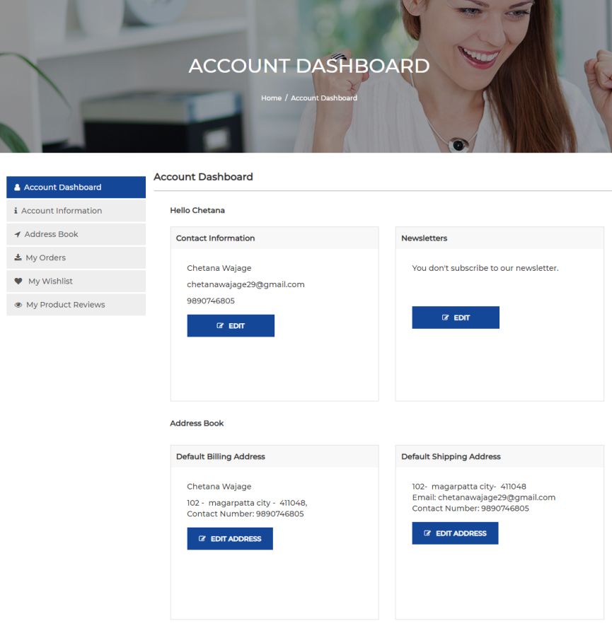

Figure - Account Dashboard

Account Information

* On this page, it will show the customer’s profile information which was entered at the time of account creation.
* Personal information includes the mobile number, first name, and last name.
* The customer can edit the profile details
* On this page, it will show the already filled data for few fields which are entered by the admin at the time of account creation.

**Available Fields**

* Below fields are available in the form
  + First Name (text field) – This field is to enter the first name of the full name
  + Last Name (text field) – This field is to enter the last name of the full name
  + Mobile Number (text field) - This field is to enter the mobile number.
  + Change Email (checkbox) – Selecting this checkbox will show fields to change email
  + Email (text field) - This field is to enter the email address.
  + Current Password (text field) - This field is to enter the current account password
  + Change Password (checkbox) - Selecting this checkbox will show fields to change the password
  + Current Password (text field) - This field is to enter the old password
  + New Password (text field) - This field is to enter the new password
  + Confirm New Password (text field) - This field is to repeat the account password which is entered in the new password field
  + Eye (icon) - This is to view & hide the password.
  + Submit (button) - This button is to update the entered data.

**Validations**

* All fields are mandatory.
* If the customer missed any mandatory fields then it will show an error after clicking on the ‘Submit’ button.
* The customer has the facility to view the text entered in the password field by clicking on the show eye icon and can again hide the text entered in the password field by clicking on the hide eye icon.
* The validation for the first & last name fields are as follows
  + The field should include only alphabets (uppercase, lowercase characters)
* For the email field are standard email validation must be followed
* The validation for the mobile number field is as follows
  + This field must accept characters as per country validation (10)
  + Only numbers are accepted
* The validation for the password field is as follows
  + This field must be case sensitive
  + In the password field, spaces are not allowed at the beginning and the end
  + This field should min 6 & max 40 characters
  + The field should include anything from alphabets, symbols, and digits

**Result**

* If the customer missed any mandatory fields then it will show an error message “This field is required”
* If the customer enters the invalid first name & last name then it will show an error message “Name should only contain letters”
* If the customer enters the invalid mobile number then it will show an error message “Please enter valid mobile number”
* If the customer enters the invalid email id then it will show an error message “Please enter valid email”
* If the customer enters the invalid password then it will show an error message “Current password isn't valid.”
* If the password does not match with confirm password field, it will show an error message “Password do not match”
* After clicking on the ‘Submit’ button, it will validate all data and update the details
* It will show success message “User data updated successfully”
* If the new password does not match with confirm new password field, it will show the error message “Password do not match”

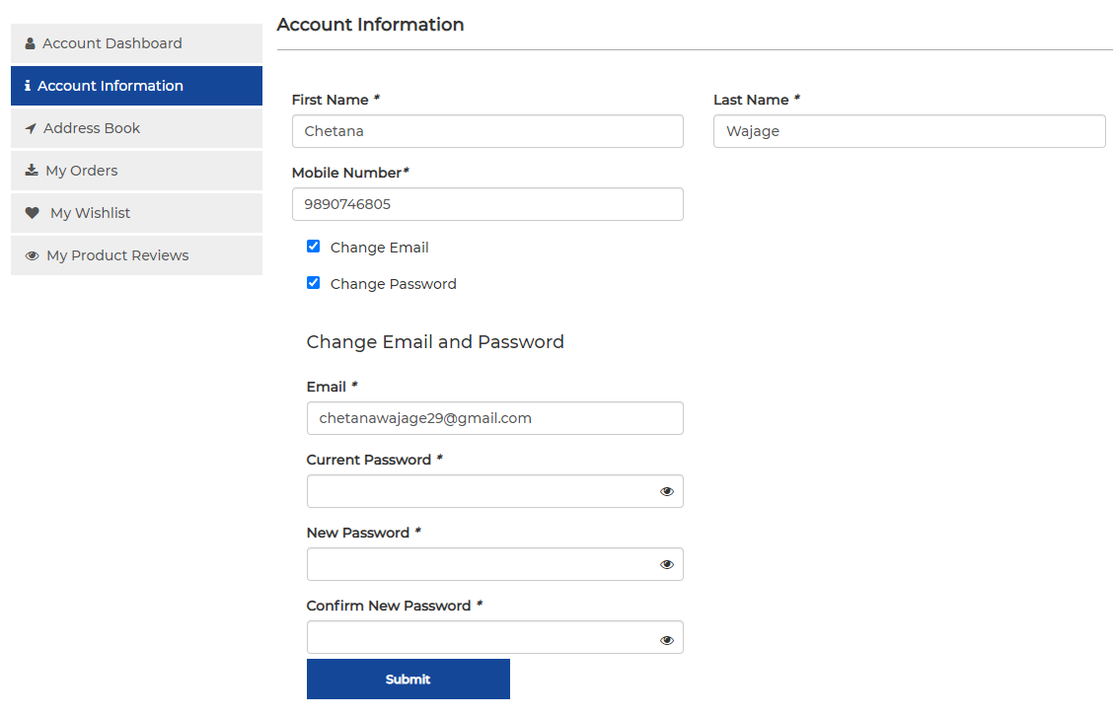

Figure - Account Information

Saved Cards

* When a customer selects this option then it will show the listing of all previously saved debit/credit card details here which include bank name, card type (debit or credit), card number, name on card, and expiry date.
* These saved cards will be populated at the time of checkout when a customer selects the credit/debit card as a payment method.
* Edit & Delete buttons are available below the saved card to update & delete the particular card details
* The customer has the facility to add new credit or debit card details by clicking on the ‘Add Card’ button.
* On click of ‘Add Card’ button, it will open a page to enter card details

**Available Fields**

* Below fields are available in the form
  + Card Number (text field) – This field is to enter the card number
  + Name on card (text field) - This field is to enter the name of the cardholder
  + Expiry Month (dropdown) – This field is to select the expiry month of the card. In the dropdown, it will show 01 (Jan) to 12 (Dec) month listing
  + Expiry Year (dropdown) – This field is to select the expiry year of the card. In the dropdown, it will show the listing of the 2020 year to 2049 years
  + Save (button) – This button is to save the card details
  + Cancel (button) – This button is to close the page

**Validations**

* All fields are mandatory.
* If the admin missed any mandatory fields then it will show an error after clicking on the ‘Save’ button.
* The validation for the name on card field is as follows
  + This field include only alphabets (uppercase, lowercase characters)
* The validation for the card number field is as follows
  + This field should include only 16 characters
  + This field should include only digits

**Result**

* After clicking on the ‘Save’ button, it will save the card details and redirect to the saved card listing page
* On click of the ‘Cancel’ button, it will close the page and show the saved card listing page.

Address Book

* When a customer selects this option then it will show the listing of all previously saved delivery address details here which include address type, contact details like name & mobile number, and address details like zip/postal code and address
* The customer can choose a saved address from the address book at the time of checkout.
* Edit & Delete options are available below the saved addresses to update & delete the particular address
* The customer has the facility to add new delivery address details by clicking on the ‘Add New Address’ button.
* On click of the ‘Add New Address’ button, it will open a modal to enter the new delivery address

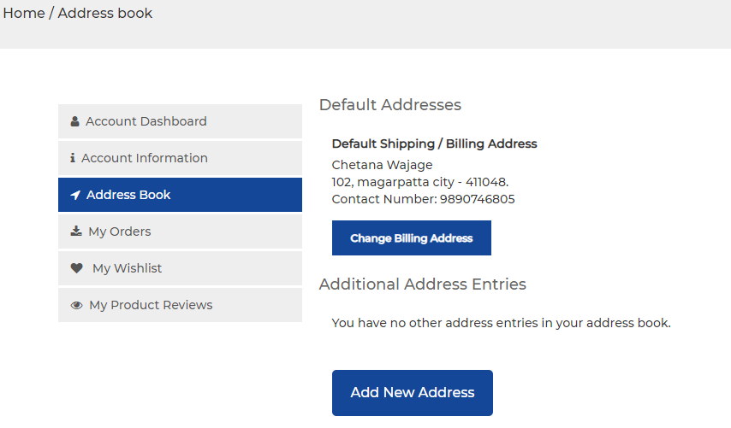

Figure - Address Book

**Available Fields**

* Below fields are available in the modal
  + Full Name (text field) – This field is to enter the full name
  + Mobile Number (text field) - This field is to enter the mobile number.
  + Email (text field) – This field is to enter the email address
  + House No./Office No. (text field) – This field is to enter the house/office number
  + Address (text field) – This field is to enter the address
  + Zip/Postal code (text field) – This field is to enter the pincode of the area
  + Address Type (dropdown) – This field is to select the address type. In the dropdown, it will show options like Home (All day delivery), Office/Commercial (Delivery between 10 AM – 5 PM), Relative (All day delivery), or Friend (All day delivery)
  + Save Address (Button) – This button is to save the address
  + Cancel (Button) – This button is to close the modal

**Validations**

* Full name, mobile number, email, zip/postal code, address, and address type fields are mandatory.
* If the admin missed any mandatory fields then it will show an error after clicking on the ‘Save Address’ button.
* The validation for the full name field is as follows
  + This field should include only alphabets (uppercase, lowercase characters)
  + This field should not include symbols, digits, punctuation, or characters from multiple languages
* The validation for the mobile number field is as follows
  + This field must accept characters as per country validation (10)
  + Only numbers are accepted
* For the email field are standard email validation must be followed
* The validation for the zip/postal code field is as follows
  + This field must accept only 6 characters
  + Only numbers are accepted
* The address field will have auto complete fashion i.e. when an admin starts type town or city name then the address will appear in the dropdown.
* The admin will select the address from the dropdown

**Result**

* If the user missed the email field then it will show an error message “Please enter your email.”
* If the user missed the address type field then it will show an error message “Please select Address type.”
* If the customer enters the invalid full name then it will show an error message “Name should only contain letters.”
* If the customer enters the invalid mobile number then it will show an error message “Please enter valid mobile number.”
* If the customer enters the invalid email then it will show an error message “Please enter valid email.”
* If the cutomer missed the address field then it will show an error message “This feild is required”
* After clicking on the ‘Save Address’ button, it will save the address details and redirect to the address book page
* It will show the success message after adding address “Address added successfully.”
* After clicking on the ‘Cancel’ button and close icon, it will close the modal and show the address book page.

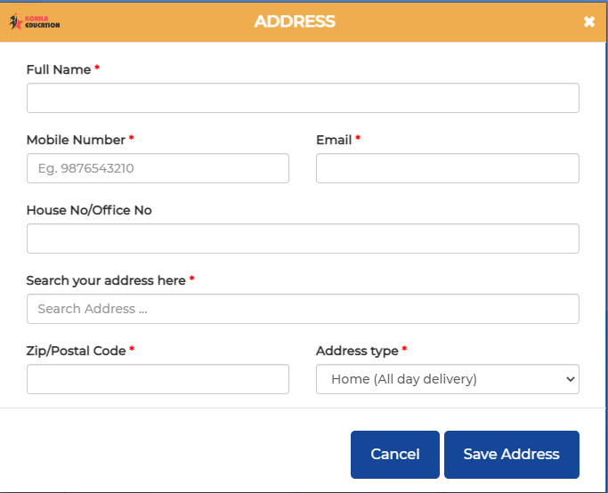

Figure - Add New Address

My Product Reviews

* When a customer selects this option then it will show the listing of various purchased products on which the customer has submitted their reviews
* It will show the count of items on which the customer has given their rating & review.
* The details of the review will include product name, product image, rating given, review given, and review date.
* Edit & Delete options are available below the review to update & delete the particular review

My Wishlist

* When a customer selects this option then it will show a listing of products added to the wish list.
* On this page, it will display product details which include a product image, product name, brand name, and price.
* If any discount is offered by the admin for a particular product then it will show the original price with a strikethrough, price after discount, and discount in percent. E.g., ~~Rs.1000~~ Rs. 600 (10% Off)
* Clicking on a particular product image, the customer will redirect to the product detailed page.
* The customer has the facility to remove the particular product from the wishlist by clicking on the delete icon.
* The customer can also move a particular product from the wishlist to the cart for purchase by clicking on the ‘Move to Cart’ button.
* If the product added to the wishlist is out of stock then on th eproduct image it will show ‘Out of Stock’ sticker/message.
* The customer will get an email notification when the whishlist product comes to stock.

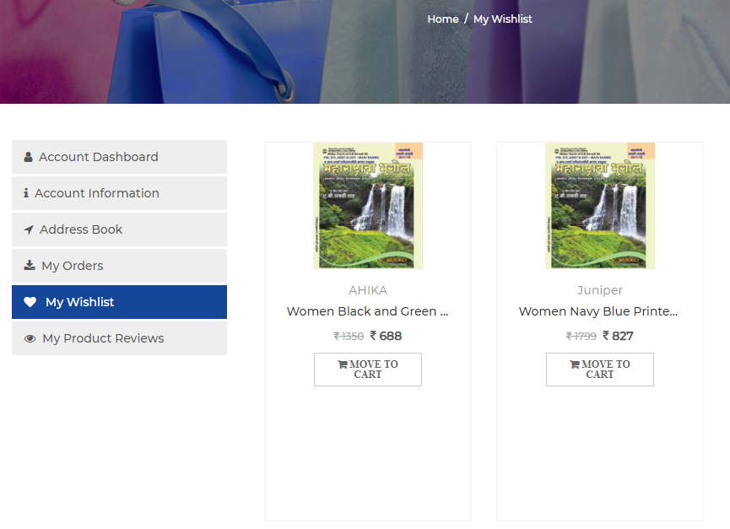

Figure - My Wishlist

My Orders

* When a customer selects this option then it will show the listing of all his placed orders.
* On this page, for each order, it will display details like Order id, product name, product image, size, color, price, quantity, ordered date, status, and ordered total.
* For each order, it will show order tracking status.
* In order tracking, it will show status like order placed, out for delivery, in transition, and delivered.
* When the order status change, it will show the date & time of the change below that status.
* Cancel, Invoice, and Rate Product buttons are available for each order.

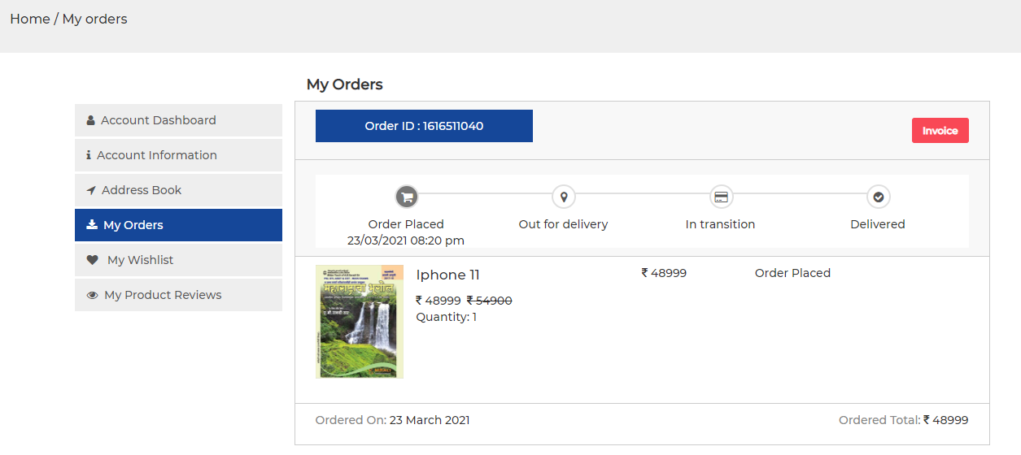

Figure - My Orders

Invoice

* Clicking on the ‘Invoice’ button will show the order invoice page.
* On this page, it will show order invoice details.
* Order details include order id, order date & time, shipping time, shipping address, payment method, order summary (cart total, shipping, discount, tax, order total, and total amount), and product details (product image, product name, color, size, price, quantity, and subtotal)
* Clicking on particular product name link, it will redirect the user to product details page.
* The ‘Print Receipt’ oprion is available on this page to print the order invoice.

Cancel Order

* The customer has the facility to cancel the order by clicking on the ‘Cancel’ button for each order.
* The customer can cancel the order before the order status is set for ‘Out for Delivery’
* Clicking on ‘Cancel’ button, it will open a popup where it will show specific reason listing to cancel the order.
* The user can select any reason from pre-defined options to cancel the order.
* The customer also has facility to write their own reason in the given textbox.
* After entering the reason the customer will clicks on ‘Cancel’ button and then it will change the order status to ‘Cancelled’
* Any amount paid of the order will be credited into the same payment mode using which the payment was made at the time of order place.
* If the customer had selected Pay on Delivery then there is no amount to be refunded because they haven't paid for their order.
* For payments made via Credit Card, Debit Card, Net Banking, or Wallet, the customer will receive refund into the source account within 7-10 days from the time of order cancellation.

Rate Product

* This option will be available to the customer once the order is delivered to them.
* When a customer selects this option for the purchased product then they can see 5 stars below the product name & image.
* The customer can rate the product on a scale of 5, where 0 stands for very poor 5 stands for excellent.
* The customer can also write their review for the product by clicking on the ‘Write a review button and it will show a textbox to enter the comment and also give the facility to the customer to upload the photo or video of the product.
* Once the customer clicks on the ‘Submit’ button, the system will automatically send an email to the admin informing them about the customer posting a review.
* The admin will approve or reject the review.
* When a customer post a review and ratings and the admin approves it, then the system will automatically pick up the customer’s name and contact details (email address, phone number, and address) to be displayed along with his review and rating for that product.
* In case the admin decided to reject any review and ratings, then he can reject the same giving a valid and logical reason. The same will be emailed to the person who has submitted the review and ratings along with the reason given by the admin.

Return Product

* The customer will have the facility to return the delivered product within 10 days in case of physical damage.
* This option will be available to the customer once the order is delivered to them.
* If the particular order contain multiple items and user want to return only few items from that order then he has facility to select the items which they want to return from that order.
* The customer will select the delivered product which they want to return, click on the ‘Return’ option, and then it will open a listing of reasons why they want to return the product.
* The customer will select the reason from pre-defined reasons or manually enter the reason.
* The customer need to confirm that the product is unused with original tags intact and click on ‘Confirm Pickup’ button then it will showcase the pickup address which is same as delivery address.
* The customer has facility to change the pickup address.
* After confirming the pickup address the customer will click on ‘Refund’ button to make product return request.
* Once the customer raises a request, they will get an email and sms confirming that their request is being processed.
* At any time, the customer can track the status of their return requests from “My Orders” section of your account.
* Once the request is raised by the customer for return, the admin will be notified.
* Based on the item, the customer request may be automatically approved or they may be contacted for more details.
* If the request is approved, the admin will ask the delivery guy to take the product back.
* During Pick Up, delivery agent may do a quality check on the return.
* After the item is pick up by the delivery agent, the admin will initiate a refund for the return amount into the payment mode selected at the time of placing the order request.
* If customer has selected the pay on delivery as payment method then in that case the refunds will be processed either to their bank account (via NEFT) or virtual wallet account.
* If the customer wishes to receive the pay on delivery order’s refund to their bank account, then they can update the details of the bank account.
* Note: Refunds cannot be processed to third-party accounts. The name on your account should match with the name of the bank account holder.
* If the customer wishes to receive the pay on delivery order’s refund to wallet then they will select the ‘Wallet’ option and the order amount for the returned product will be added to the site wallet as virtual payment to the customer account.
* The customer can used the amount added in the wallet after returning the product for further purchase on the site.
* The refund amount is expected to reflect in the customer account as per the following timelines:
  + Netbanking- 1 to 3 business days post refund initiation
  + Wallet- Instant
  + Online Refund (Credit/Debit card) – 7 to 10 days post refund initiation, depending on your bank partner
  + UPI wallet – Instant